**EDAM Studio** Installation Guide

2023-01-21

# How to Install EDAM Studio

The current version of EDAM requires to do some previous configuration and installation of resources by hand before running the application for the first time.

## Step 1.0 Preparing the EDAM Database

Make sure to have MS-SQL Server installed before going through the installation steps. It has been tested in 2019, and 2022 Developer, Express, Local and Community versions. Once SQL Server is available open the EDAM Database project, run publishing it to the installed server. Make sure to update the related connection string as required in the next Step.

### Step 1.1 Add Reference Data

Publishing the database does not run the scripts to insert code-sets, go to the “Scripts” folder and run all scripts related to reference data.

## Step 2.0 Deployment Package

The (msix) Deployment Package (Edam.Studio.x.x.x.x_x64_Test) can be found in the “Edam.Install/Edam.Studio.AppPackages” folder in the main project folder. Make sure to read the “READ-ME-FIRST.md” file first and follow the instructions.

# Running the App for the First Time

Properly configured as stated in the previous section the first time the App is run it will prompt for some basic identity information as shown in the next Figure:

Some sample values are provided. Understand that the “Agency ID” or “Organization ID” should be a single word not greater than 20 characters to identify the “Tenant” organization. Since the application has been configured as Local the above information is encrypted and stored somewhere and to help retrieve those values next time a Pin number is required and for this reason the next screen follows:

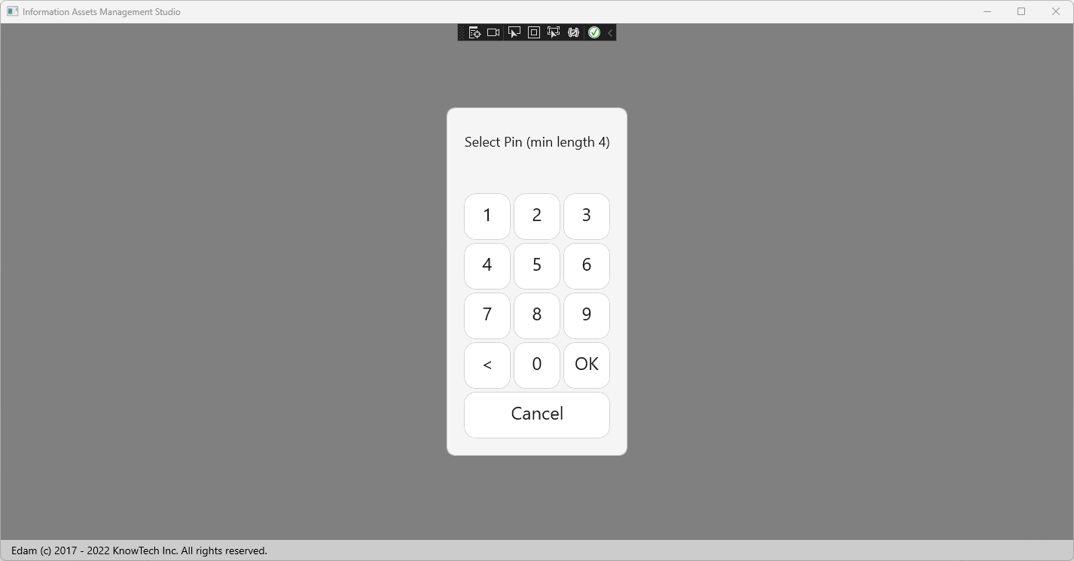

Enter a Pin number that will be requested next time the App is run.

To continue review other documentation provided in the “Documents” folder.